Name
Tutor
Course
Date
The Whale and Ale restaurant
A week ago I had the pleasure of visiting Los Angeles, California. I had some business meeting with a certain producer, a friend of mine who resides in Los Angeles. The business meeting took too long, so I had to spend the night. He booked a reservation at a British Restaurant in Los Angeles. I have always loved the British, so I was glad to have their food. I have never been to a British restaurant before, so when I was greeted with the sexy British accent, I felt like I had flown to London. The Hotel is designed using the Victorian style. To me, it appeared like a fiction hotel in Charles Dickens novel. The interior of the restaurant follows some British tradition, which makes the place more appealing. I decided to try three different kinds of foods so I could choose one. The waiters and waitresses were British, talked with this great accent and curtsied when serving around. I was reminded of Arthurian movies, where I saw people curtsying. The dinner was simply amazing.
The restaurant I visited is called The Whale and Ale. The restaurant I located in 7th street, San Pedro, Los Angeles. The waiters and waitresses were active and approached the customer immediately after settling down. They spoke politely and explained things clearly since most of the foods are foreign. I tried speaking in French, and the waiter replied to me, meaning they knew several languages. They helped me in choosing by telling me every ingredient in every meal they were serving. They even told me the cultural value of the foods they were serving to the British. The owner was walking around and approached our table. Since the hotel served British food, I was curious to ask him why he had chosen to open a British restaurant in California. He informed that most of his customers were British actors and actresses who worked and lived in Los Angeles. He mentioned that he has many American customers who either came with their British friends or came alone and loved the foods they were serving. He gave me a little history of the foods they sold and their significance to the Britons.
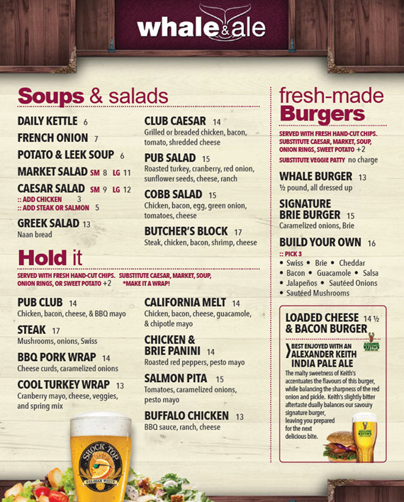
One of the foods I tasted was the beef wellington, prime rib and fish, and chips. The beef wellington was great, just like the prime rib. However, the fish and chips were amazing. According to the owner, the fish and chips had more history back in England. People loved the fish and chips than the other foods in England. The fish and chips were the best meal the restaurant offered. The British are known for being fast or for doing things faster. The owner told me they liked them since frying the fish was easy and because frying the chips was easy too. Taking foreign foods has never been a greater experience. The waiters told me every little detail about the food, which made it easy to choose. There was a screen on the wall that showed the different foods contained in the menu, with their ingredients, which made choosing the foods easier. I felt comfortable when taking the food, because of the treatment I got from the waiters and waitresses.
The dishes I tasted are common dishes. They are not taken during special occasions in Britain. Like the fish and the chips is sold in fast food centers. However, during a special occasion, its taken as the main course. The Beef and Wellington is also not taken during special occasions only. The British are known for their love for chips and fish. Therefore, this meal is unique to them because of the way they prepare it. It had a lot of spices, which were sliced and applied uniquely. I expected to see everyday chips when I placed the order. However, I received a very different kind of food. The spices used on the fish include coriander, ginger, carrots, cucumber, lemon and some garlic. The cooking process included frying the fish and then serving it. Before frying, the fish was inserted in a bowl of wheat flour, which made some pieces of the flour stick to the fish. Upon inserting it in the boiling oil, the flour stuck on the fish, which increased its sweetness when served. The spices were applied to the fish after frying it. Most of the spices were uncooked or lightly steamed, which made them sweeter and healthier.
This food would fit in my own cultural and personal pattern of eating. The preparation method is quite easy. Also, the ingredients used are plenty in the place where I live. Moreover, fish is allowed to be taken in my tradition and potatoes for making the chips are plenty in my home. The food was sweet in its way, therefore preparing it would be worth it.
In summation, British fish and chips at the Whale and Ale restaurant left a great impression on my mind. The food was simple yet unique in its way. I like associating myself with Britain for reasons unknown to me. Therefore, I'll have to learn how to make British Fish and Chips since they were sweet and impressive.

